

**CS319 Object Oriented Software Engineering Project**

**Analysis Report**

**Iteration 1**

**IQ PUZZLER PRO**

**GROUP - 3G**

*Fatih Çelik*

*Cenk Er*

*Enes Yıldırım*

*Eren Yalçın*

*Burak Bayar*

*Ebru Kerem*

**Contents**

1. **Introduction**
2. **Overview**

**2.1. Online Option**

2.1.1. Create Custom Map

2.1.2. Browse High Scores

1. **Functional Requirements**
2. **Nonfunctional Requirements**
3. **System Models**

**5.1. Use Case Model**

5.1.1. Use Case Diagram

5.1.2. Use Case Description

**5.2. Dynamic Models**

5.2.1. Sequence Diagram

5.2.2. Activity Diagram

5.2.3. State Diagram

**5.3. Object and Class Models**

**5.4 User Interface**

1. **Glossary & References**

1. Introduction

IQ Puzzler Pro is a puzzle game consisting different puzzle pieces and a board. The goal of the game is to fit all puzzle pieces together onto the map. There will be different puzzle scenarios with varying difficulties. The game will include a timer, a hint box and a point system. Furthermore, there will be online version of the game where players able to create custom scenarios. They will be able to share them online for other players to compete for highscores.

The solo part of the game will start with easy puzzles and the player will need to complete them to unlock harder ones. Easier levels will have less pieces to fit. The structure of the boards will vary, some will include already inserted pieces. The point system will start with a constant value and decrease as time passes or if hints are used. The online part will not include the puzzles in the solo part, instead it will only consist of custom made maps. Every map will have a score table and popularity. To make it fair, scores will be calculated by the time past since the first start of the puzzle (no option to pause). Custom maps will require completion from their creators for all online puzzles to be completable.

2. Overview

The game can be opened with the double clicking to the icon of the game. The menu will appear which consists of online game, solo game, tutorial, options and exit buttons. Solo and online game options have different features. Solo game option’s maps are fixed. However, maps in online game are designed by users. Thus, they can be more distinct compared to solo ones. Both game option has time limit. User has to finish the game in a specific time period.

2.1 Online Option

If player would choose the online option, s/he must have the account. Player must log in to account to continue or create a new account to continue to the game . After opening the account, user can choose browse or create map. Create map option enable user to create their map and upload in the system. They can track highscores of the maps. In order to play a game, they have to browse the maps and select one of them.

2.1.1 Create Custom Map

As long as user has an account, s/he can create a custom map. The difficulty of the map is dependent on the will of the user. Only requirements for the map is to make a reasonable one. All blocks have to be used and the puzzle has to have certain answer. After created map, user can observe the highscores which belong to the map. Thus, player can figure out the complexity of his/her puzzle.

2.1.2 Browse High Scores

The maps in the online option do not have the sign which shows the difficulty level of the map. Instead of this , maps have highscores table which can show what the other players’ highest score in these maps. We assume that player can judge the map’s difficulty by looking these tables and can search for the map which is suitable for their level.

2.2 Solo Option

In the solo game option, player doesn’t have to have an account to play. After selecting solo game from the main menu, levels will be opened. Levels have their difficulty levels. Some levels are locked some are not in these different difficulty ranges such as easy, medium and hard. The locked ones can be opened if user can reach at that level. By selecting the level user wants to play, the game will start. Game has maps which contains blocks in certain places and has also other blocks which can move freely. User must complete the whole board to finish the game in a given time. Then, they can play the next level.

3. Functional Requirements

* Player can choose the volume of sound and music
* Player can play the solo puzzles (puzzles come with the application - classic puzzles)
* Solo puzzles use a 5x11 board and use 12 distinct puzzle pieces
* The puzzle pieces can be immovable and oriantable (their orientations may change)
* Puzzles have a timer
* Solo puzzles have an option to get hint (places a block to its right location)
* Solo puzzles are unlocked after prior difficulty levels are complete (starter/junior/expert/master/wizard)
* Player can choose to play online and create an account
* Player can log in to an already made account
* Player can browse and download a custom made puzzle online
* Custom made puzzles store the accounts completed them with their time used for completing
* Player can create a custom puzzle and load it to online database after finalizing it
* Custom made puzzles have an option to choose the board size and puzzle pieces (including options for immovable pieces)
* Custom made puzzles can’t be finalized before proven completable
* Player can start a tutorial puzzle

4. Nonfunctional Requirements

User Friendliness

The game should be easy to play; the puzzle piece locations, orientations, immovability (in custom puzzle creation) should be easy to change. The overall interface should be easy to understand for anyone. Any player should be able to navigate through menus to access where they want to, like observing their custom made puzzles’ highscores. A player should be able to understand what happens when they do an action, like leaving a puzzle in the middle of playing or creation.

Object Oriented Design

The structure of the application should be object oriented; there should be a close association of data structures with the functions that act on the other data. There should be proper interfaces used to increase flexibility of the application. Any further changes should be easy to implement.

5. System Models

**5.1. Use Case Model**

5.1.1 Use Case Diagram

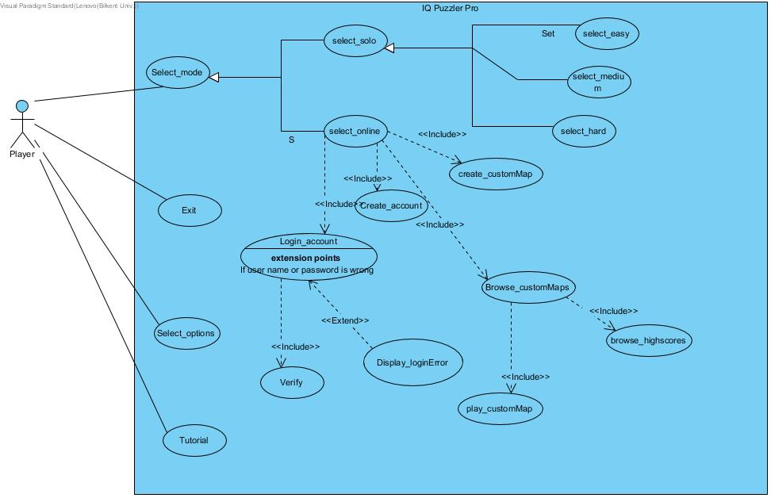

5.1.2 Use Case Descriptions





















**5.2. Dynamic Models**

5.2.1. Sequence Diagrams

**Sequence Name:** Start Game

**Scenario:** Player Ebru clicks on the game icon and main menu of the game opens. Ebru clicks on the “Solo Game” option to start playing the game. Before entering the game screen, the level selection screen opens and Ebru selects an unlocked level to play. After selecting the level, the game window initializes. While initializing the game window, first the selected level is sent to MapData class to get the pattern of the map that belongs to the selected level. This pattern is used to specify the puzzle. Then, the system requires images of the blocks from PuzzleObject class. These blocks will be ordered according to MapData. Later, the time will be initialized. After all objects initialized, the game starts by the entering game loop.

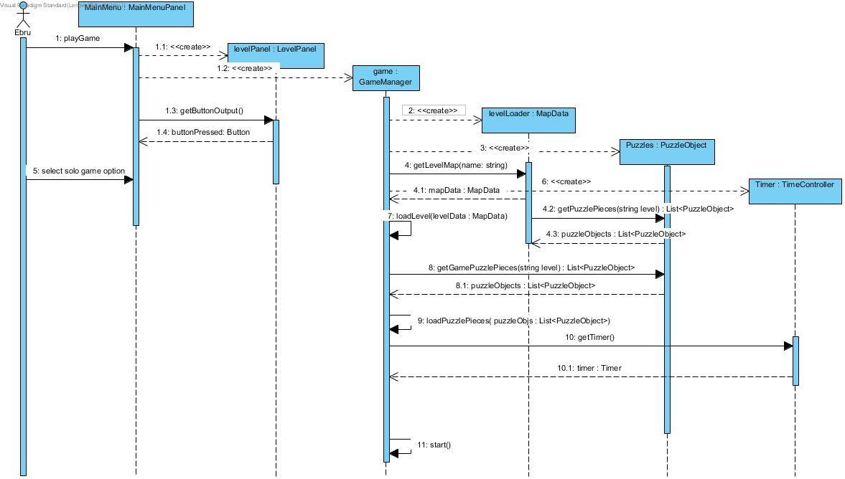

**Sequence Name:** Play solo game

**Scenario:** After player Ahmet selected the solo game option and the level he wants to play, the game loop starts. There are blocks in the specific locations in the map. These blocks can’t be moved. Other than these blocks, there are blocks which are not located. Ahmet tries to complete the map with the help of these unlocated ones. Ahmet has a time limit to finish the puzzle. He tries to finish the game before this time limit. When Ahmet put an unlocated block in the puzzle, the game is updated. Ahmet can also change the blocks direction to make them fit the blank spaces in he map. Ahmet tries to replace every pieces into the puzzle before time is over. When all the puzzle finishes, the game is over.

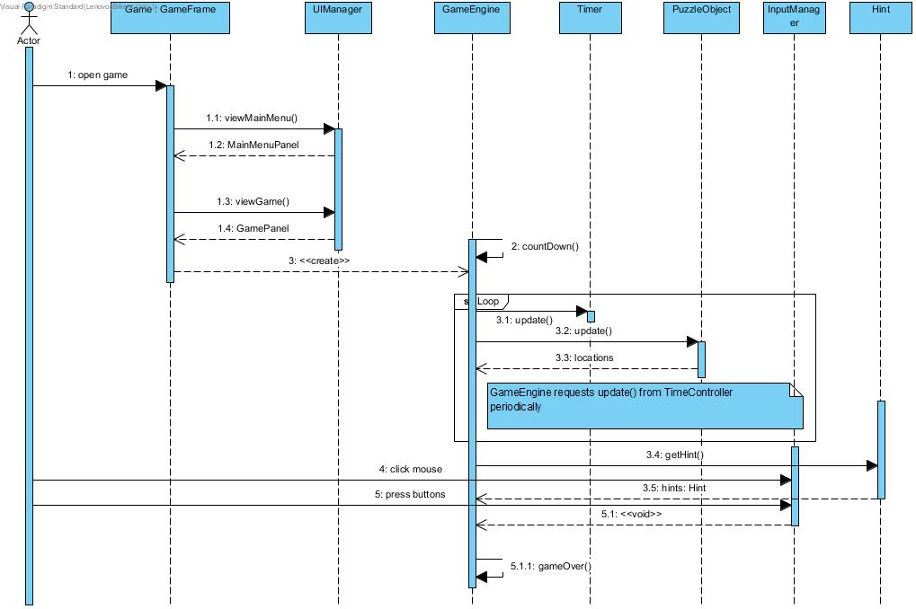

**Sequence Name:** Login to account or create Account

**Scenario:** When actor chooses the online option in the game, he/she views the login page of the game. If the actor already have an account he/she can play the online iq puzzler pro easily after typing his/her correct username, password and clicking on the login button. Also, if the actor don’t have an account they can easily get one by completing the same steps of the login part on the same page but they only have to click on the create account button. Afterwards, if the username is already taken it will ask user to pick another one. When player creates an account they will able to play the IQ Puzzler Pro online after they login.

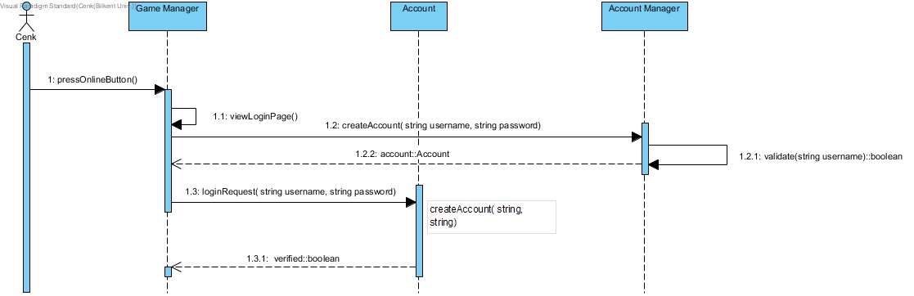

**Sequence Name:** Create a custom puzzle

**Scenario:** After an actor logs in to the online part of the game, they choose to create a custom map. They choose the size of the board by entering x and y coordinates. After setting their board size, they choose which puzzle pieces to use in their puzzle. After selecting and fitting all their puzzle pieces, they choose some pieces to be immovable. Then they complete their custom puzzle and upload it to the online database of custom puzzles which is linked to their account automatically.

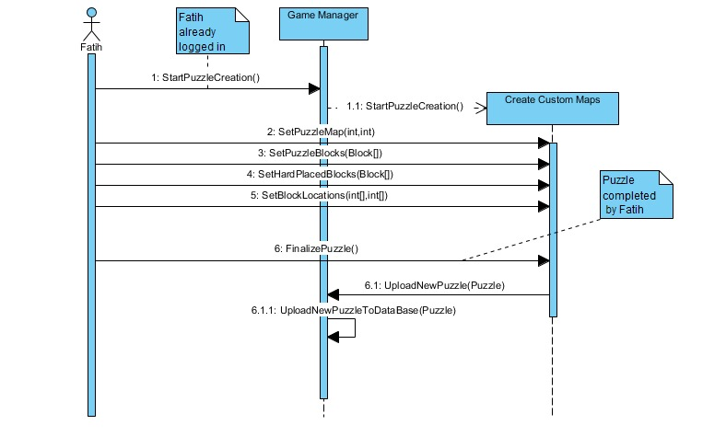

5.2.2. Activity Diagram

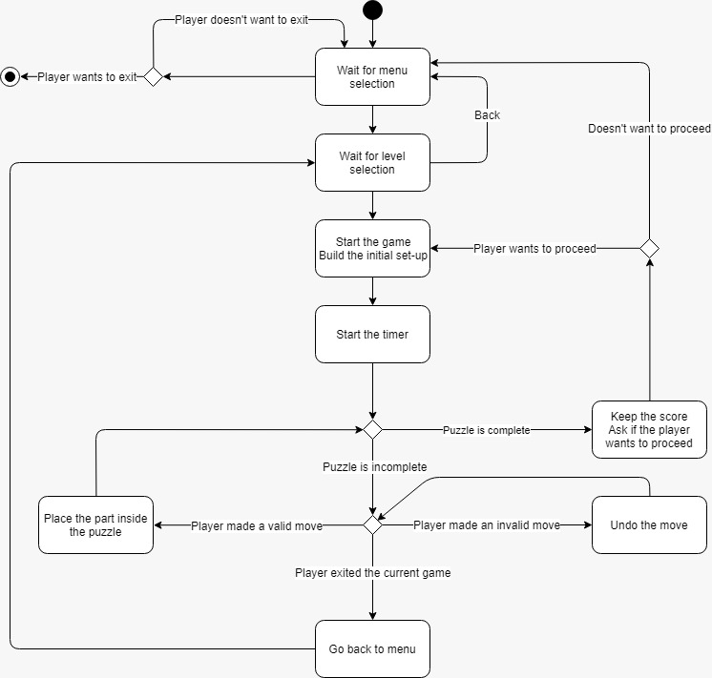

First, the program waits until the user makes a choice in the main menu. Later the user has to choose a level from the level selection grid. After the selections are complete, the program starts the game as well as the timer for that specific level.

Later, the program checks whether the puzzle is complete and then re-checks this after every valid move. If the puzzle is complete, the program asks if the player wants to proceed to the next level. If they do so, next level begins, if not, they are redirected back to main menu.

If the puzzle is not complete, the player has to make a move. If the move is a valid one, the program checks whether the puzzle is complete or not once again. If the move is invalid, the placement of the last block resets and the player gets to play the last move again.

If the player chooses to exit the game instead of making a move, he or she is redirected back to the level selection. Not redirected to the main menu because it’s a game with multiple puzzle’s so it is more likely for a player to exit a game without finishing it in order to play another puzzle rather than going back to the main menu where he or she needs to choose the game type again.

5.2.3. State Diagram

This diagram shows the behaviour of the whole system for all kinds of sequences. The initial state starts with clicking the game icon, and final state occurs by exiting from the main menu (the situation of directly clicking the toolbar exit button is neglected). This diagram does not give detailed information about how game is played or how a map is created, but it gives the information of all the user interface states in the game.

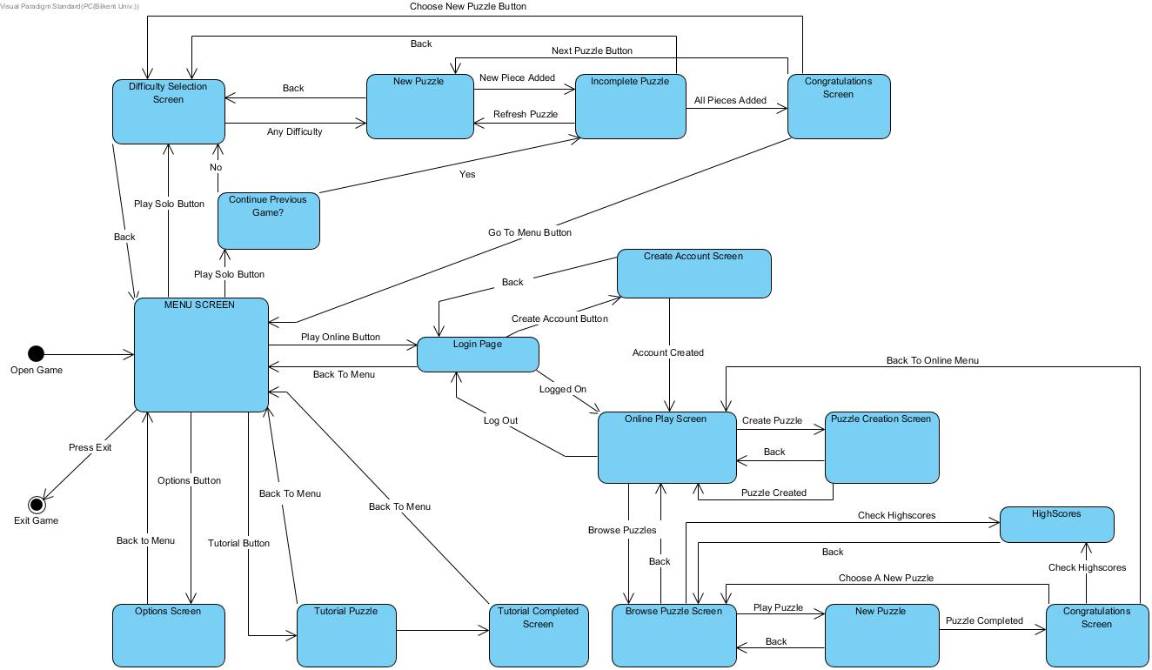

5.3.Object and Class Model

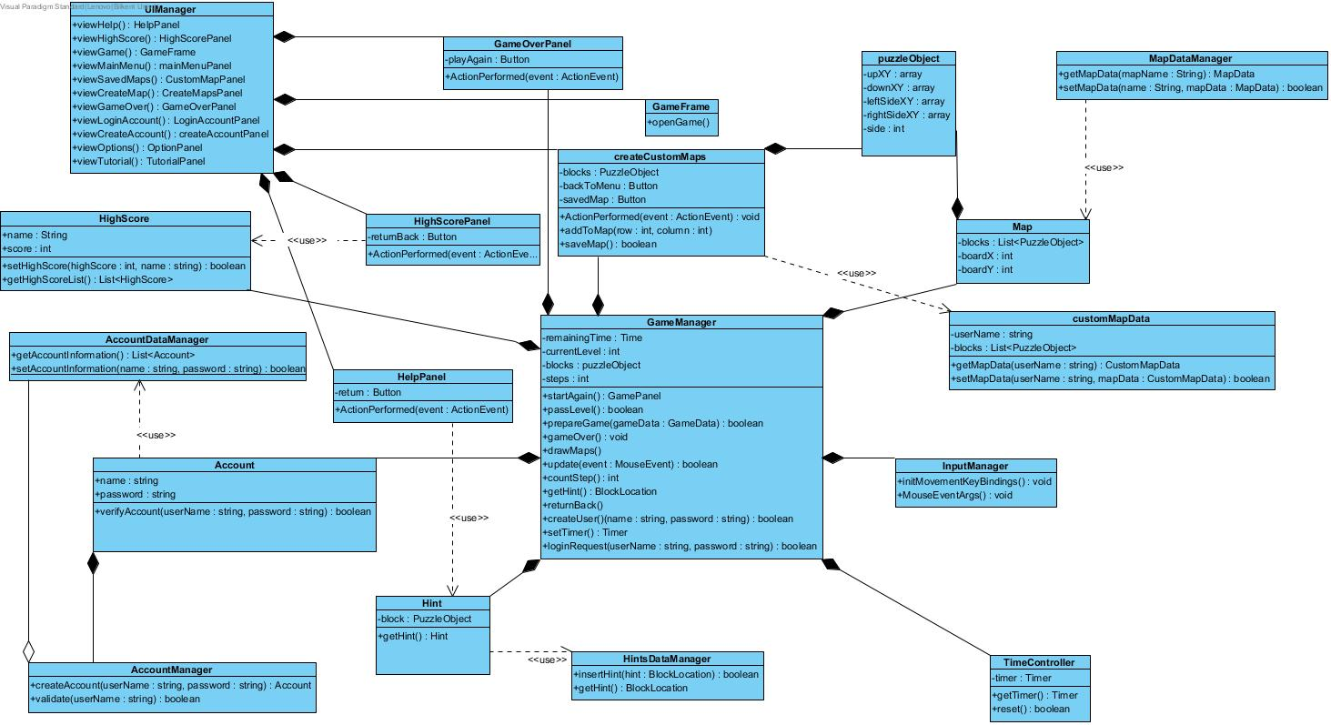

Better Resolution Can Be Seen From: <https://github.com/csLover1337/Elon-s-musk/blob/master/Reports/Class%20Diagram1.jpg>

5.4. User Interface

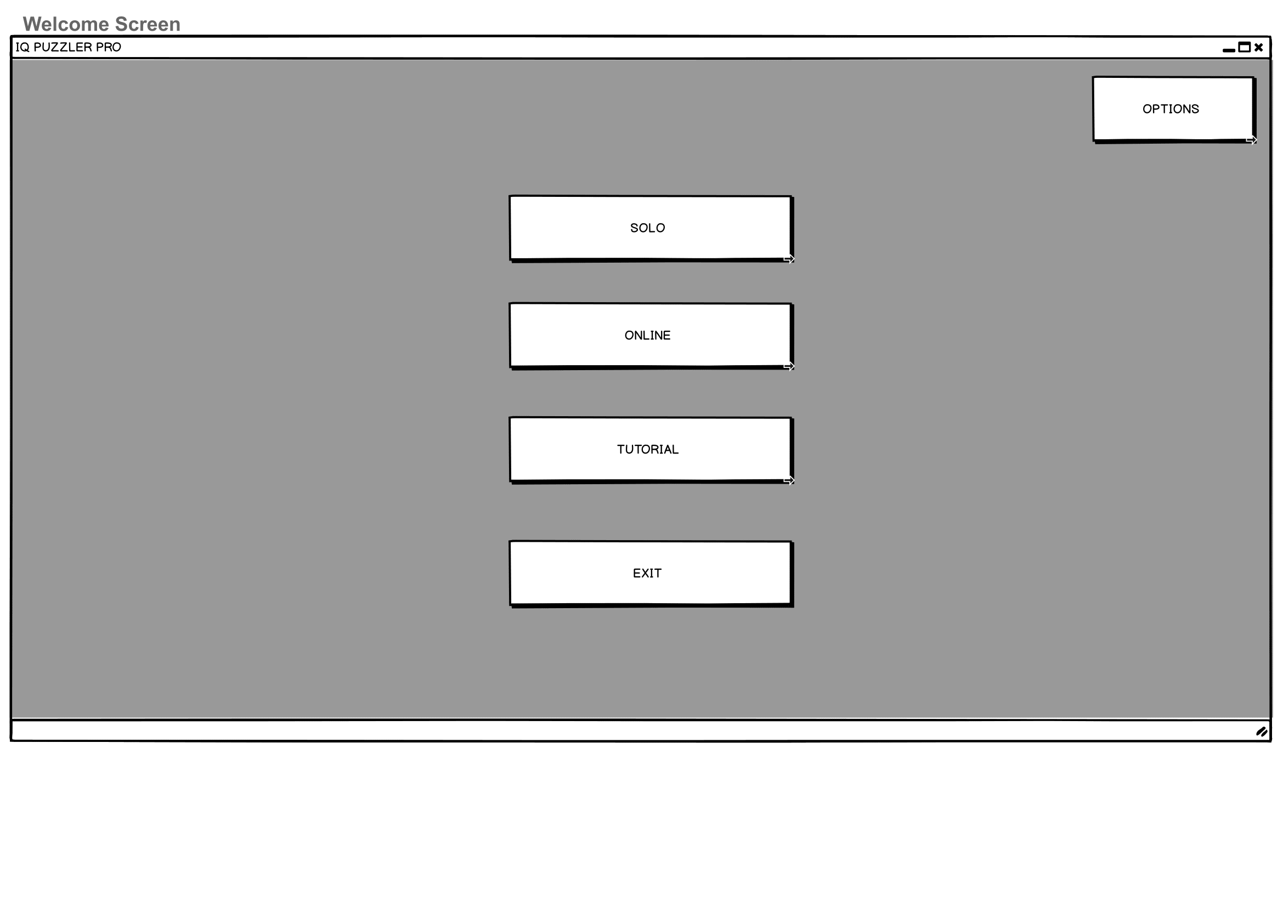

On Welcome Screen, there will be 5 buttons. Solo and Online Buttons will be leading players to play games according to their choices. Options Button is for setting Sound Effects and Music volumes. Tutorial button is for new players who does not know how to play and learn. Once the Player clicks exit button, the program will be exited.

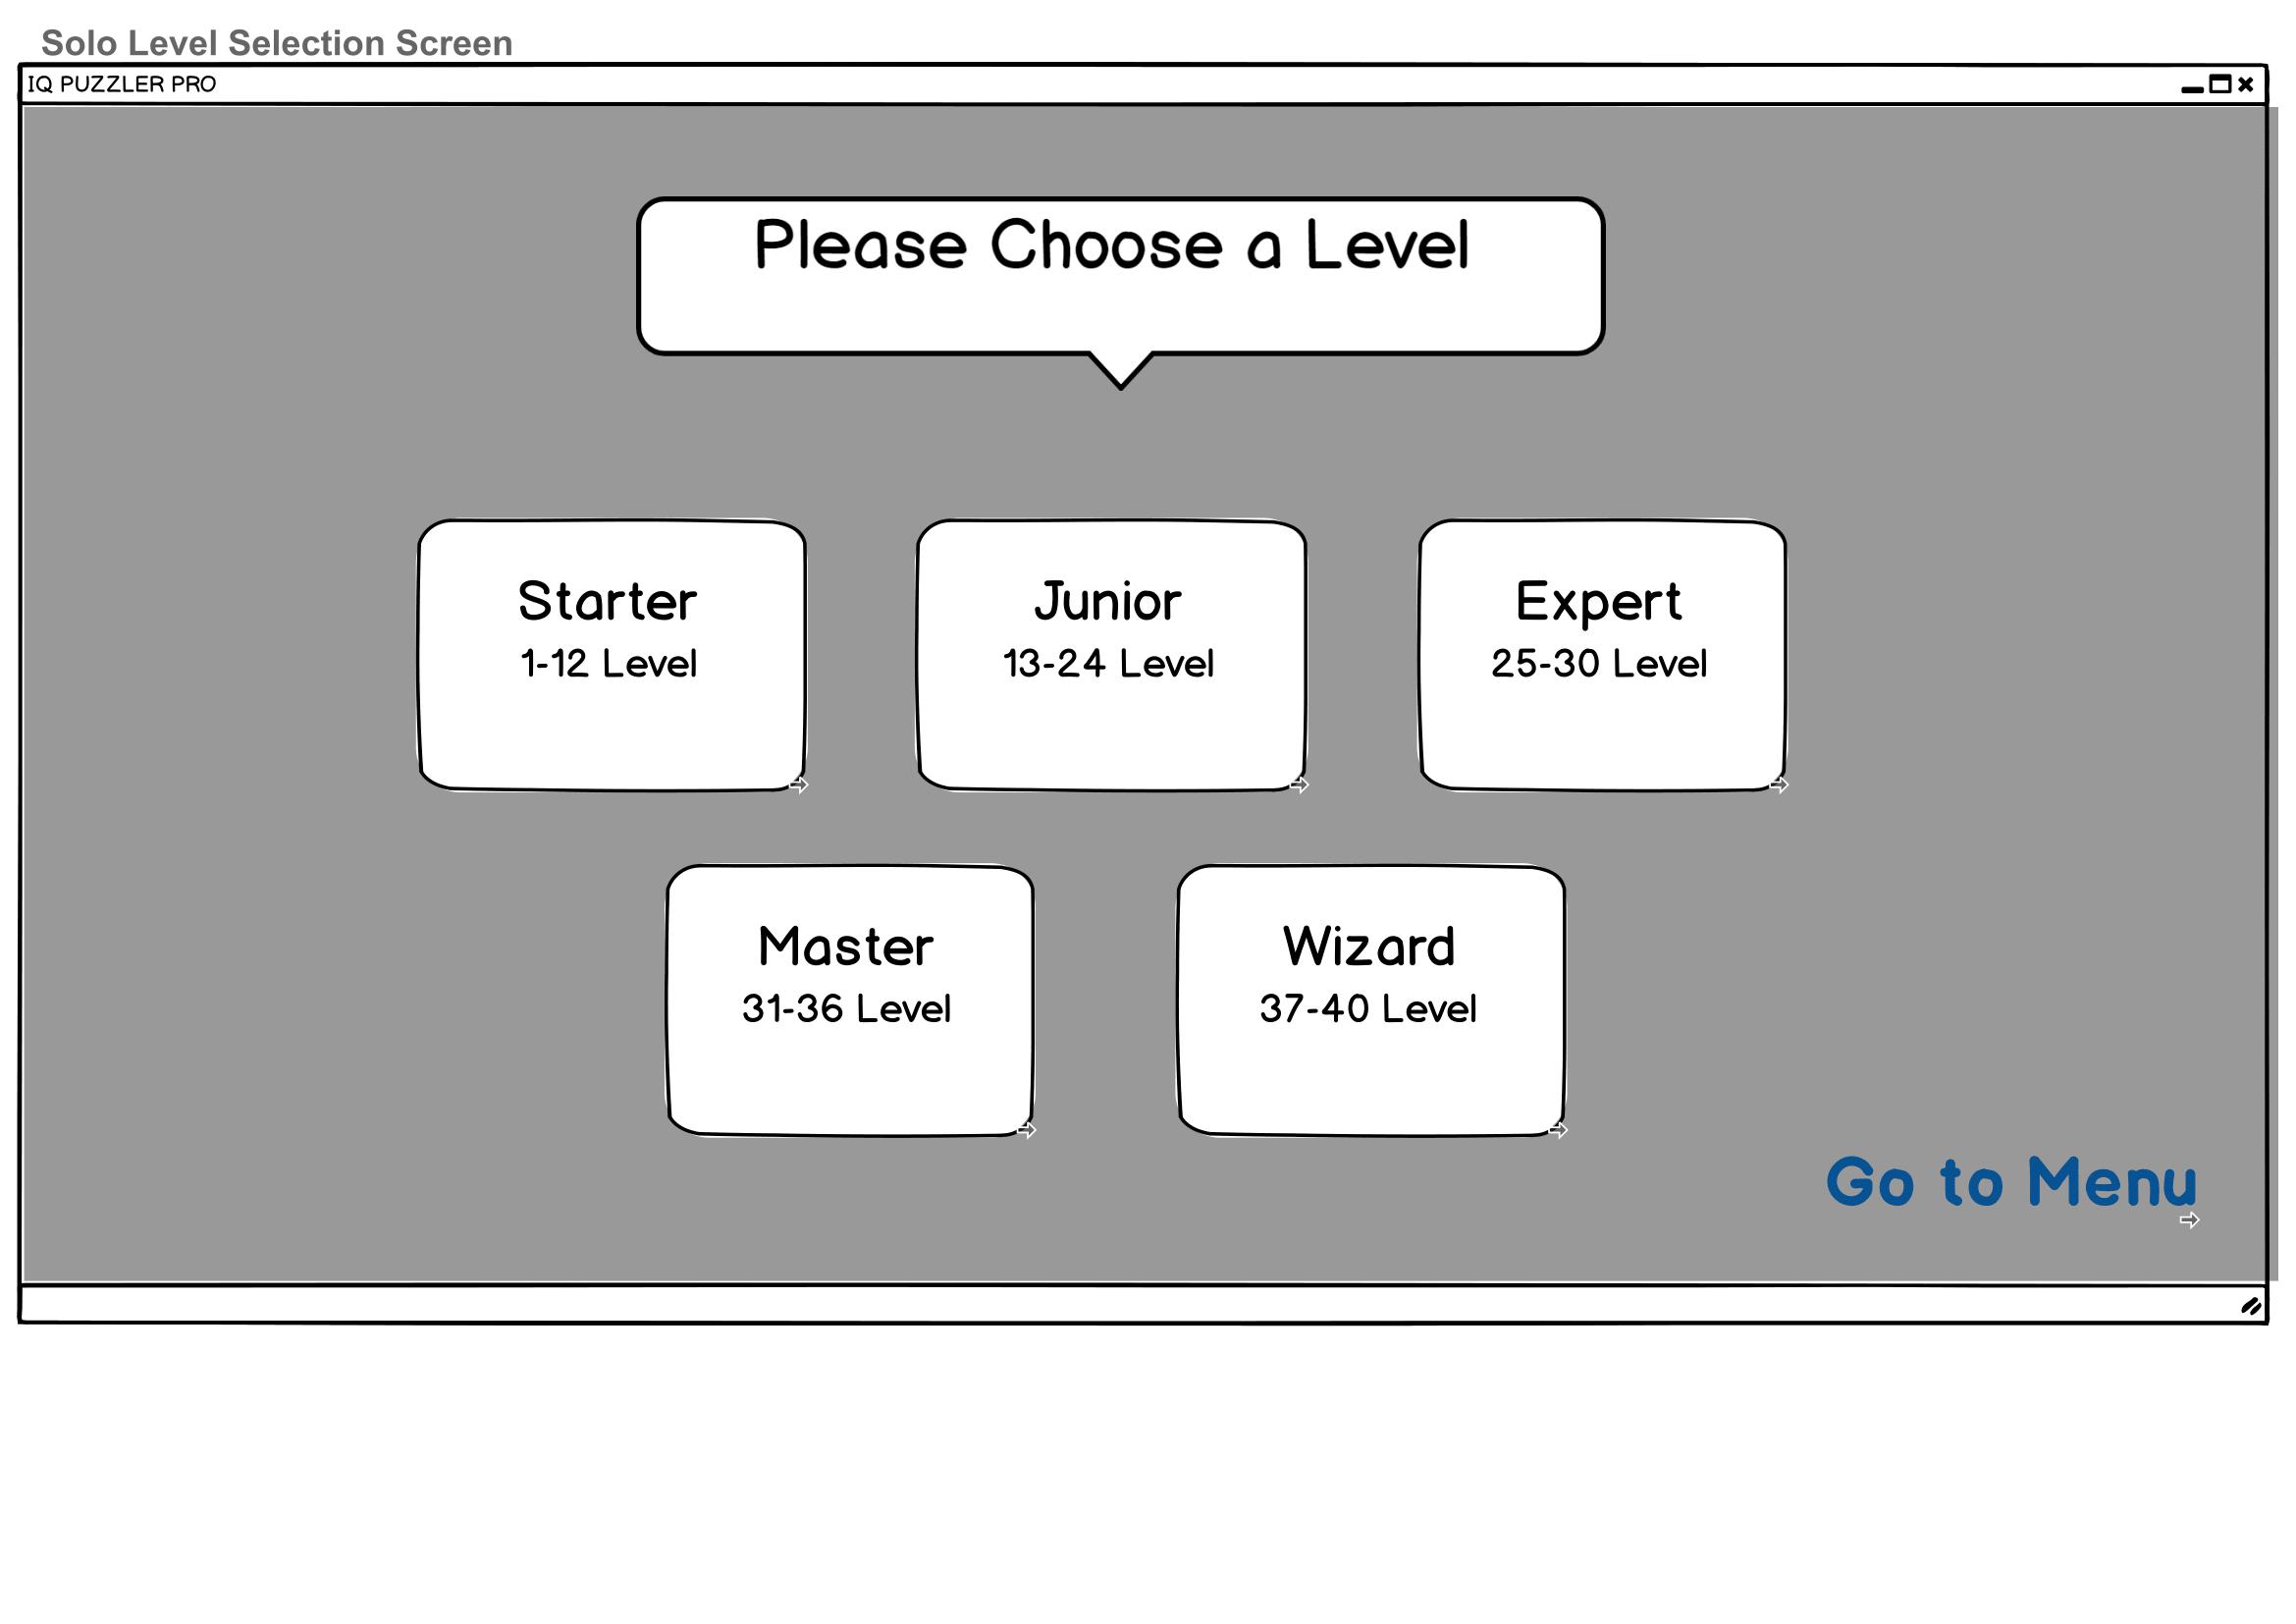

According to Real-Board Game, there are 5 difficulty levels which are Starter, Junior, Expert, Master, Wizard. Also there is a Go To Menu Button for returning to previous screen.

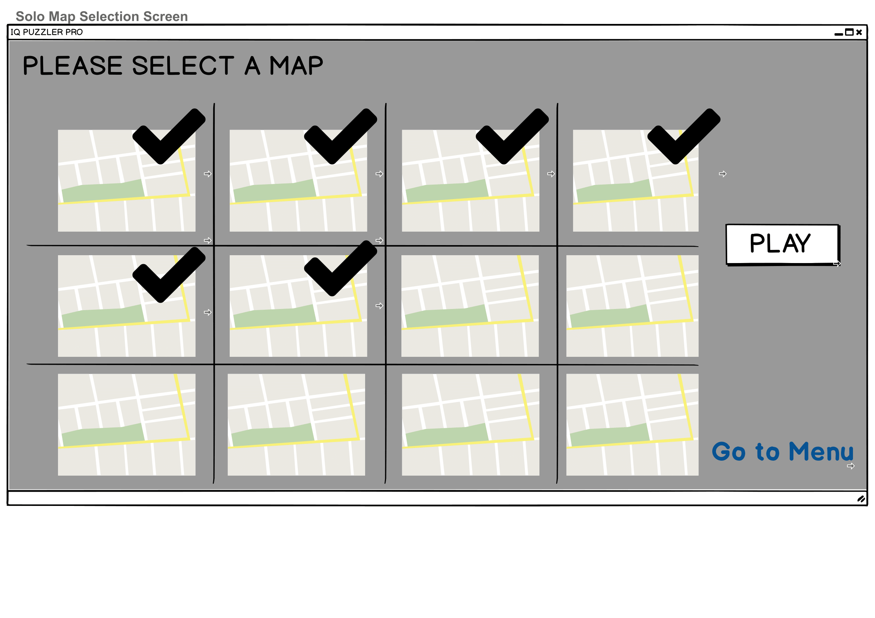

Solo Map Selection Screen will be showing all solo maps and allowing users to play selected map. If the map is completed, there will be check icon over map thumbnail. Once the user selected the map and pressed the Play button, Solo Play Game Screen will be shown.

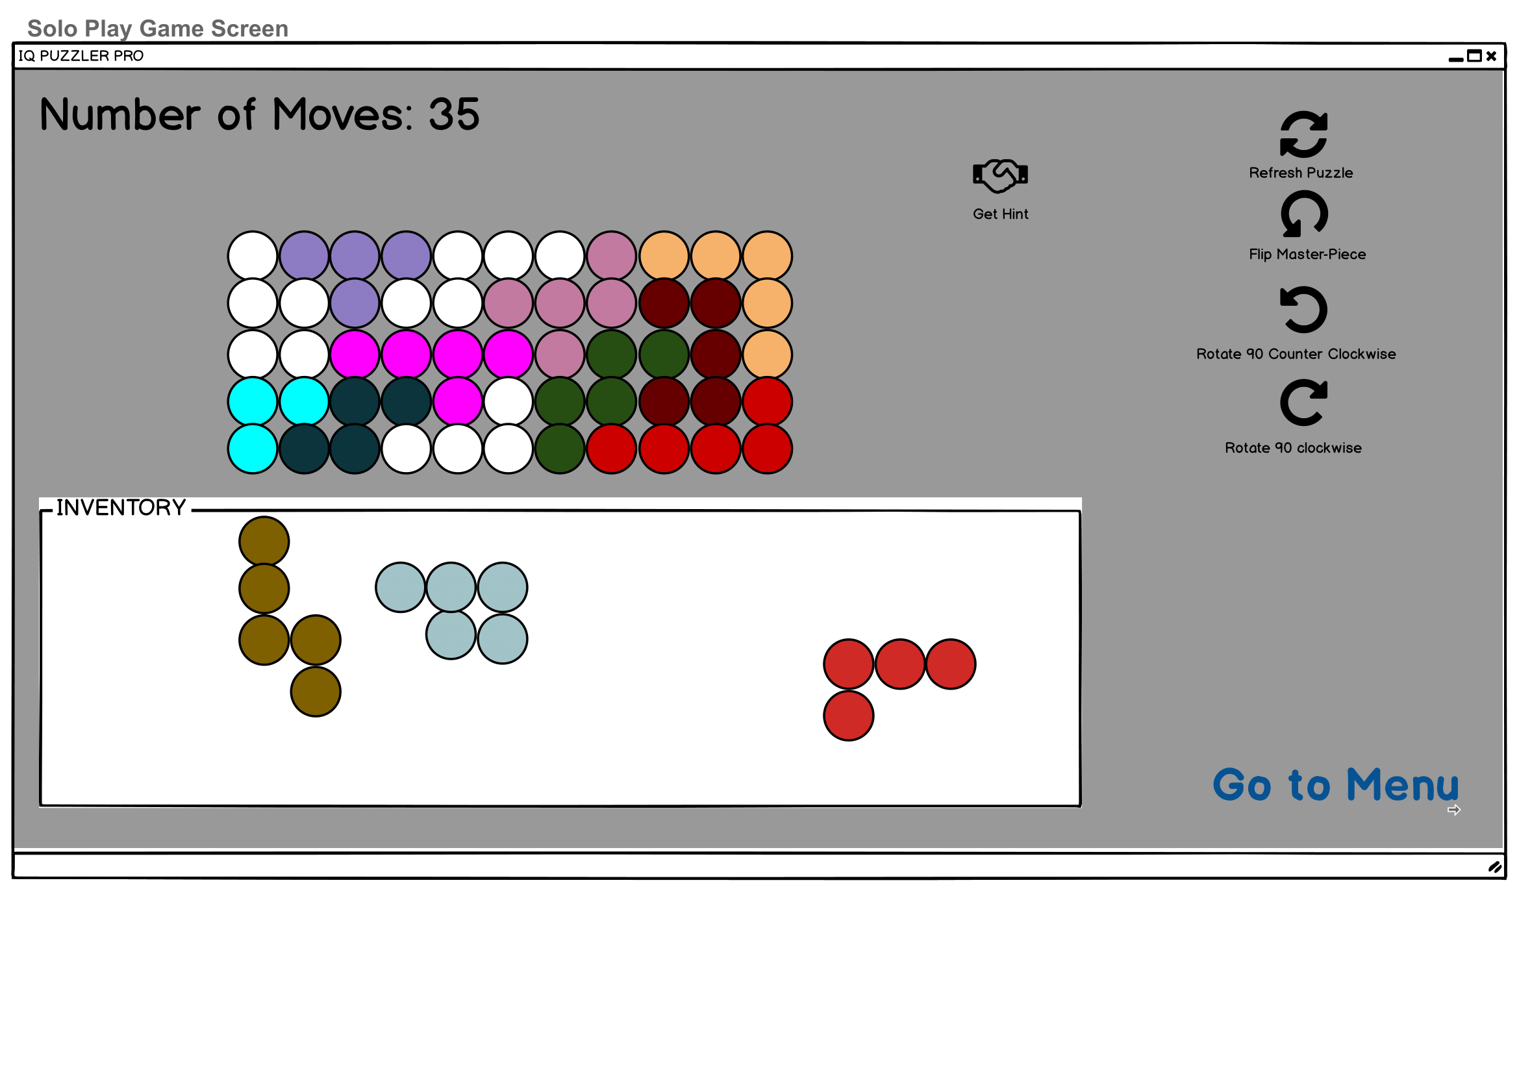

In Solo Play Game Screen, number of moves will be shown. Below, the board to be completed is located. And there is a Inventory box that includes necessary pieces that will be used to complete the board. When the Get Hint Button is pressed, hint to complete puzzle will be shown. Also on the right there are 4 buttons. One of them (Refresh Puzzle) is to undo all moves. Other ones for flipping and rotating.

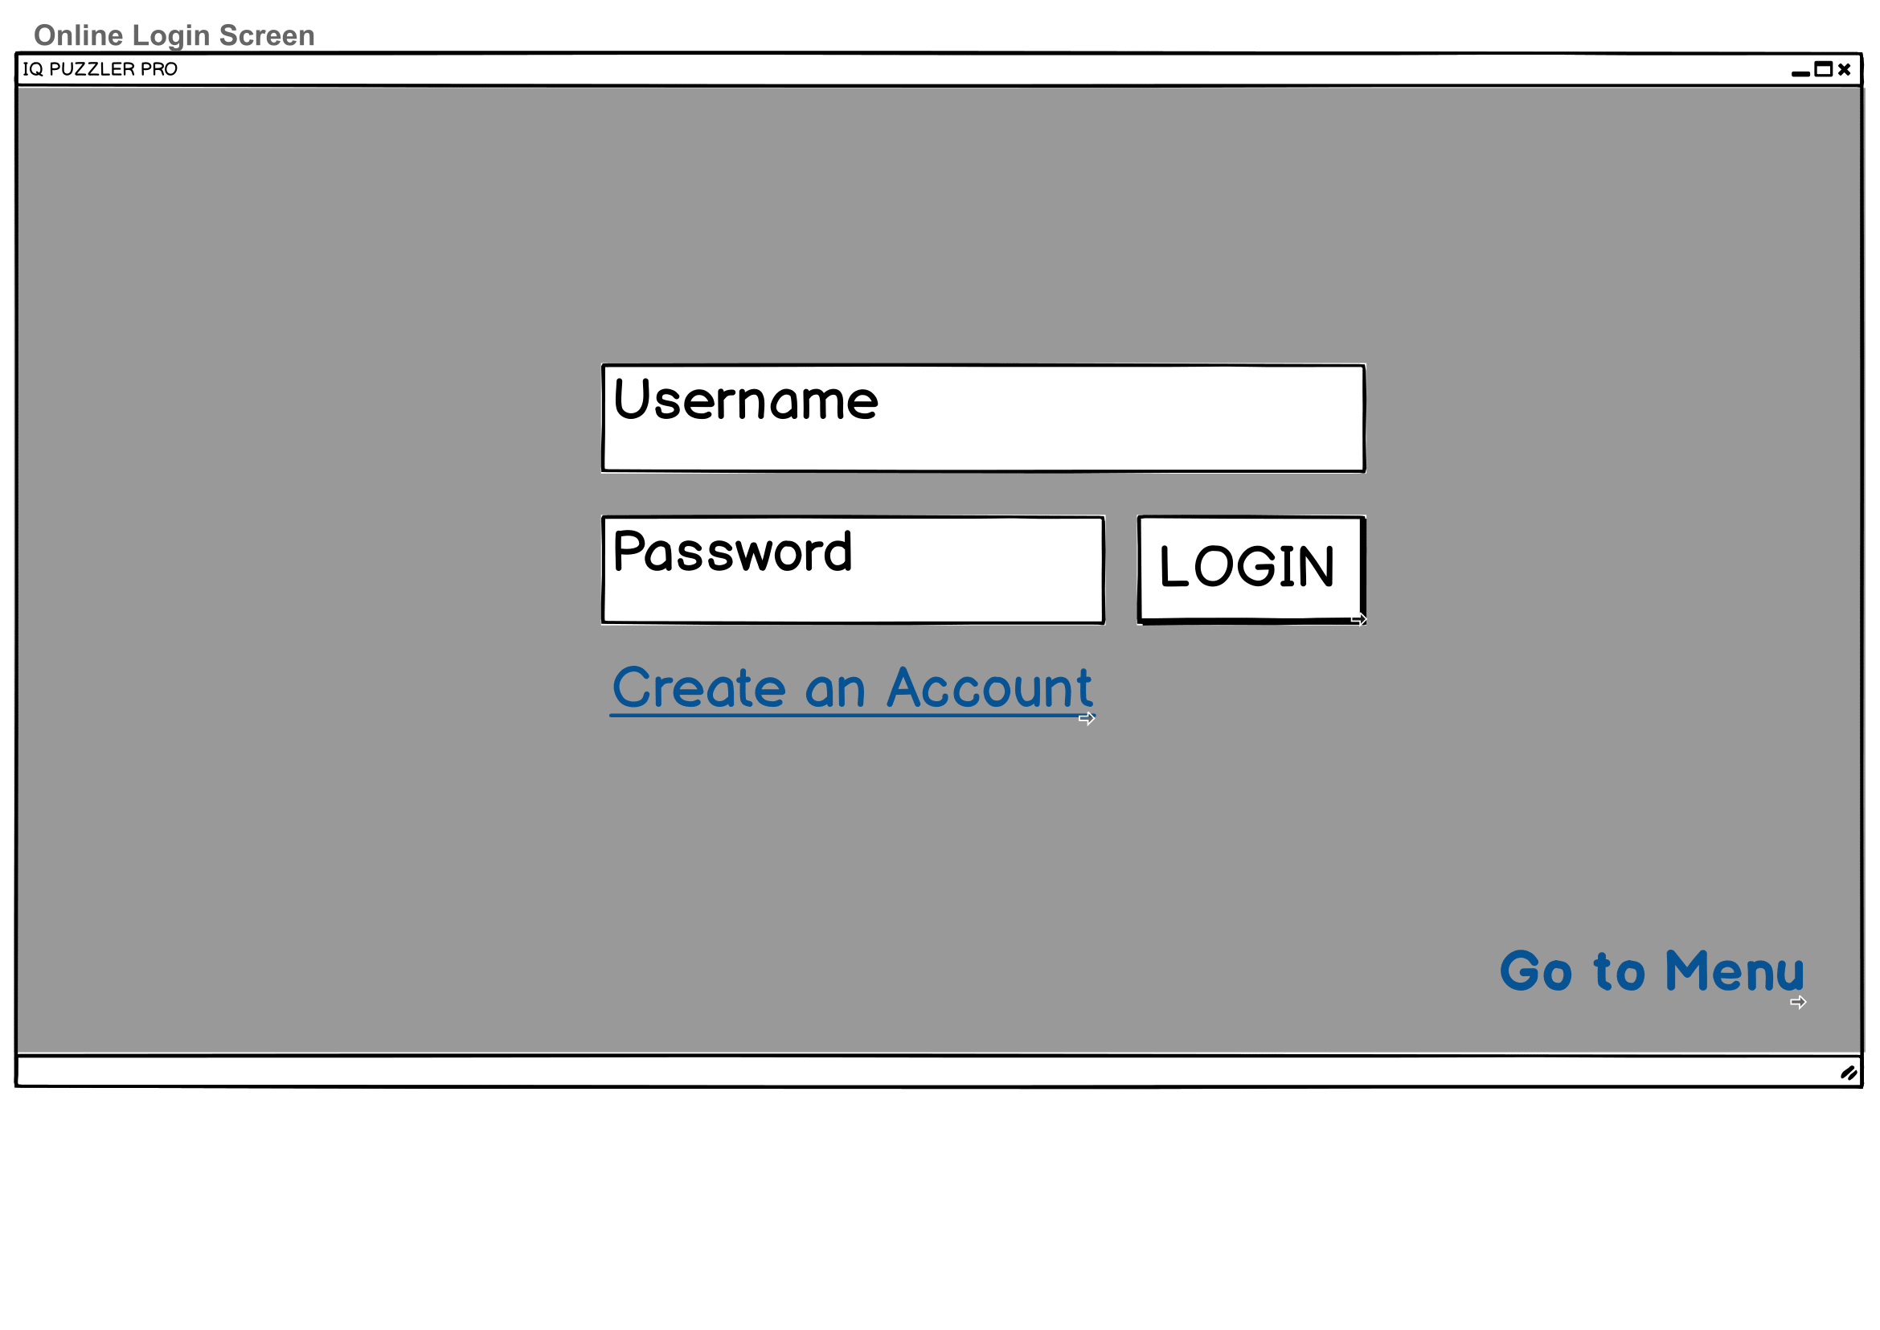

Online Login Screen has two input boxes to fill with Username and Password and Login Button if user created account. If not, there is a Create an Account link to Online Create New Account Screen.Or if the user wants to go back, there is a Go To Menu Link

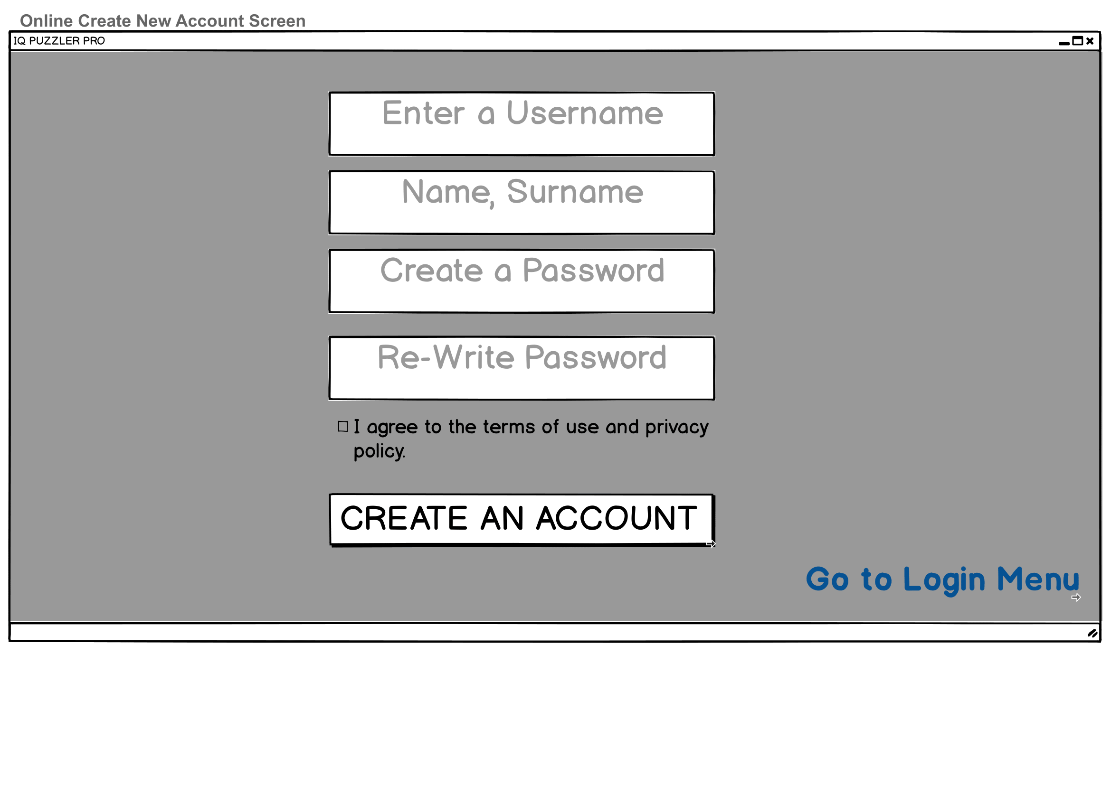

Online Create New Account Screen will be requesting Username, Name and Surname, Password and re-writing Password again. Also there will be a checkbox which is a requirement to be selected to create a new account. Once the Create An Account Button is pressed and all of pre-mentioned text boxes are filled, the program will be directing user to Online Selection Screen.Also there is a Go To Login Menu link to go back.

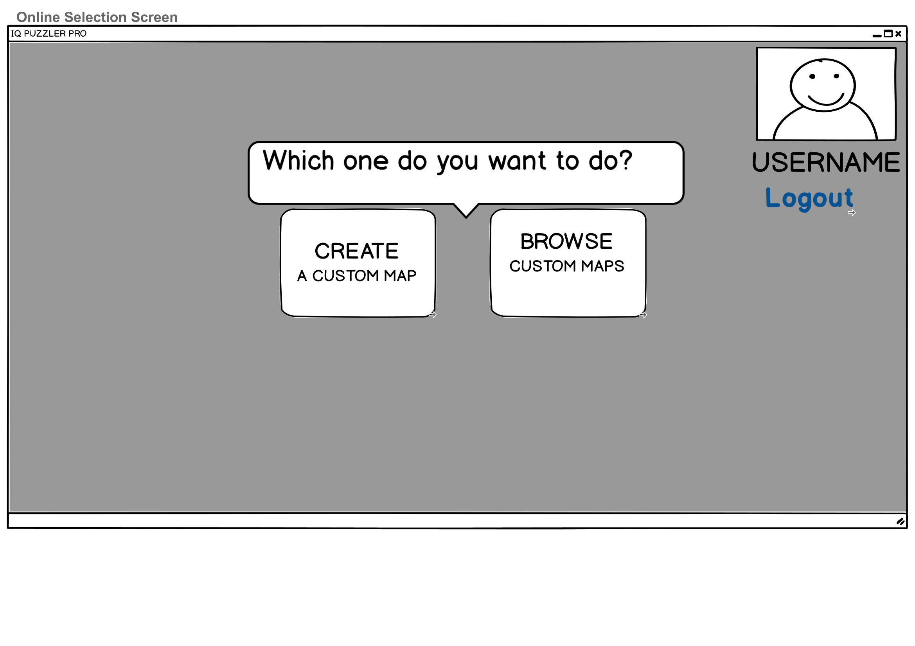

Online Selection Screen will show the image of user and username. Below, there will be a Logout Button which will be directing user to Main Menu and Logging out. There will be 2 buttons which is for creating a custom map and another for for browsing custom maps which are created by another users.

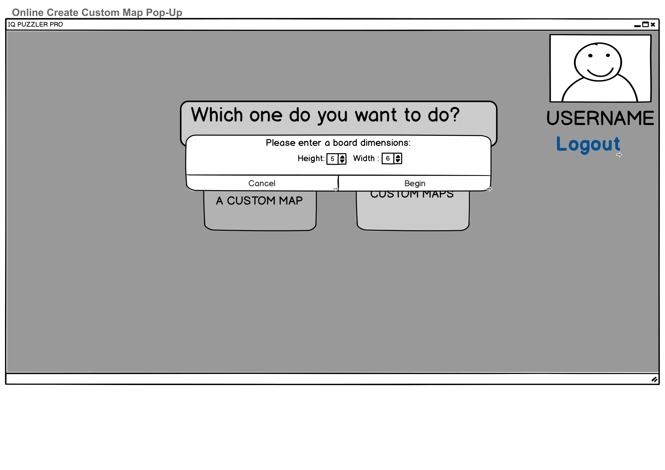

This pop-up is for user who wants to create their custom map. They will be selecting height and width of the board and once they hit the Begin Button, they will be directed to Online Create Custom Map screen with entered dimensions.

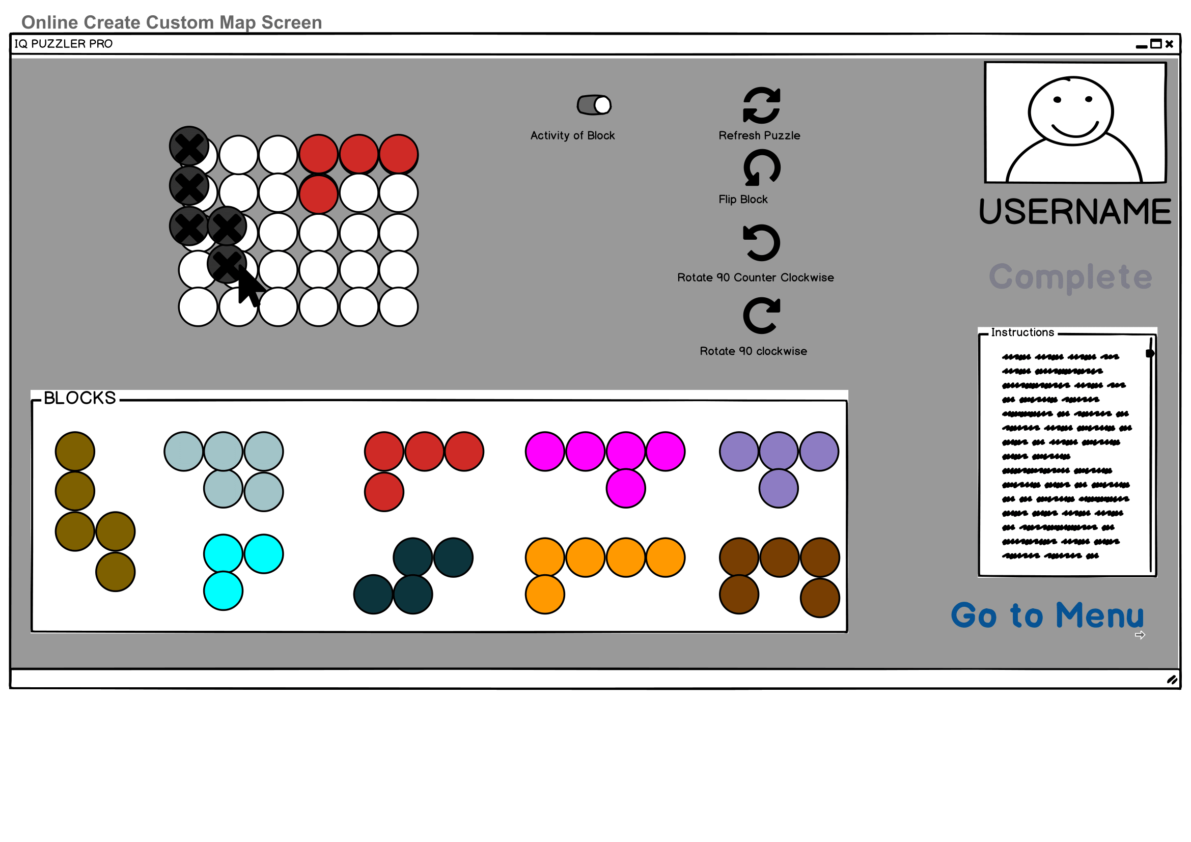

Online Create Custom Map Screen will show the board and all blocks, instructions and user details as the same as previous screens. User can deactivate some blocks such that player who plays this map cannot relocate this block. Also rotation and refresh puzzle buttons are the same as gameplay screen.

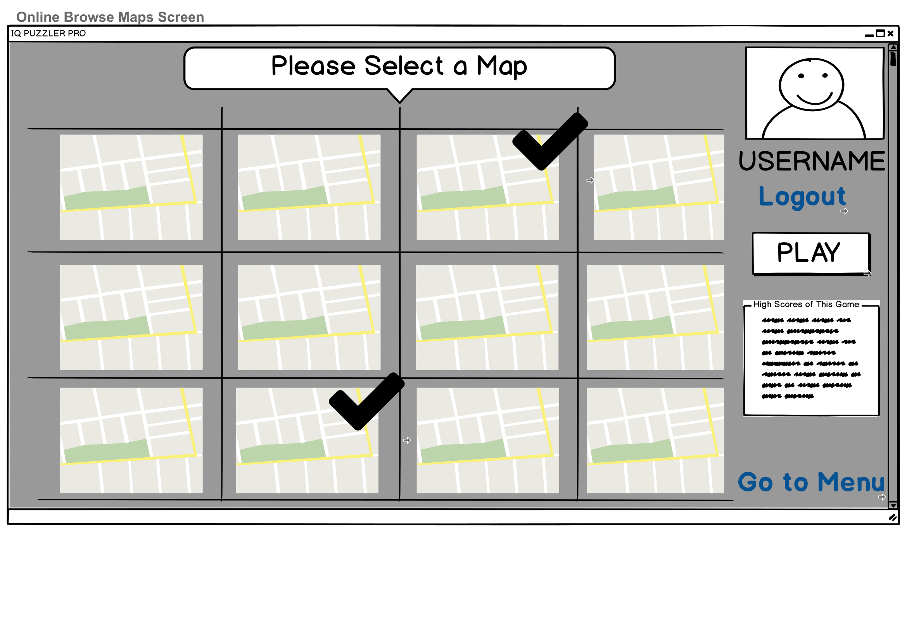

Online Browse Maps Screen will be showing all maps in ascending order with popularity.If the user played any map, there will be check icon over this map.Also when user clicks one map High Scores of this map will be shown and by clicking Play button, user will be directed to Online Play Map Screen

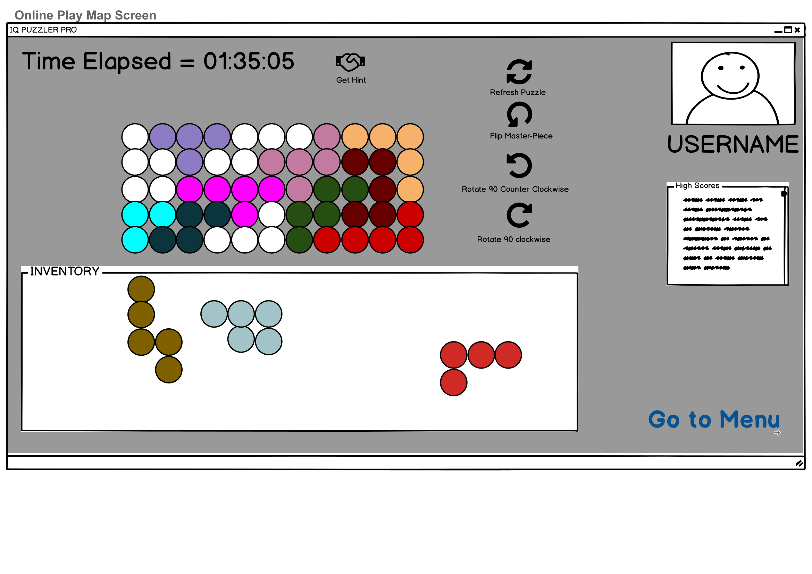

Online Play Map Screen will be counting time and displaying it on the top. Board will be completed by dragging from inventory area to board area. Right of the board, there will be same buttons as Solo Play Game Screen and their functions will be the same. User details will be shown as previous screens.

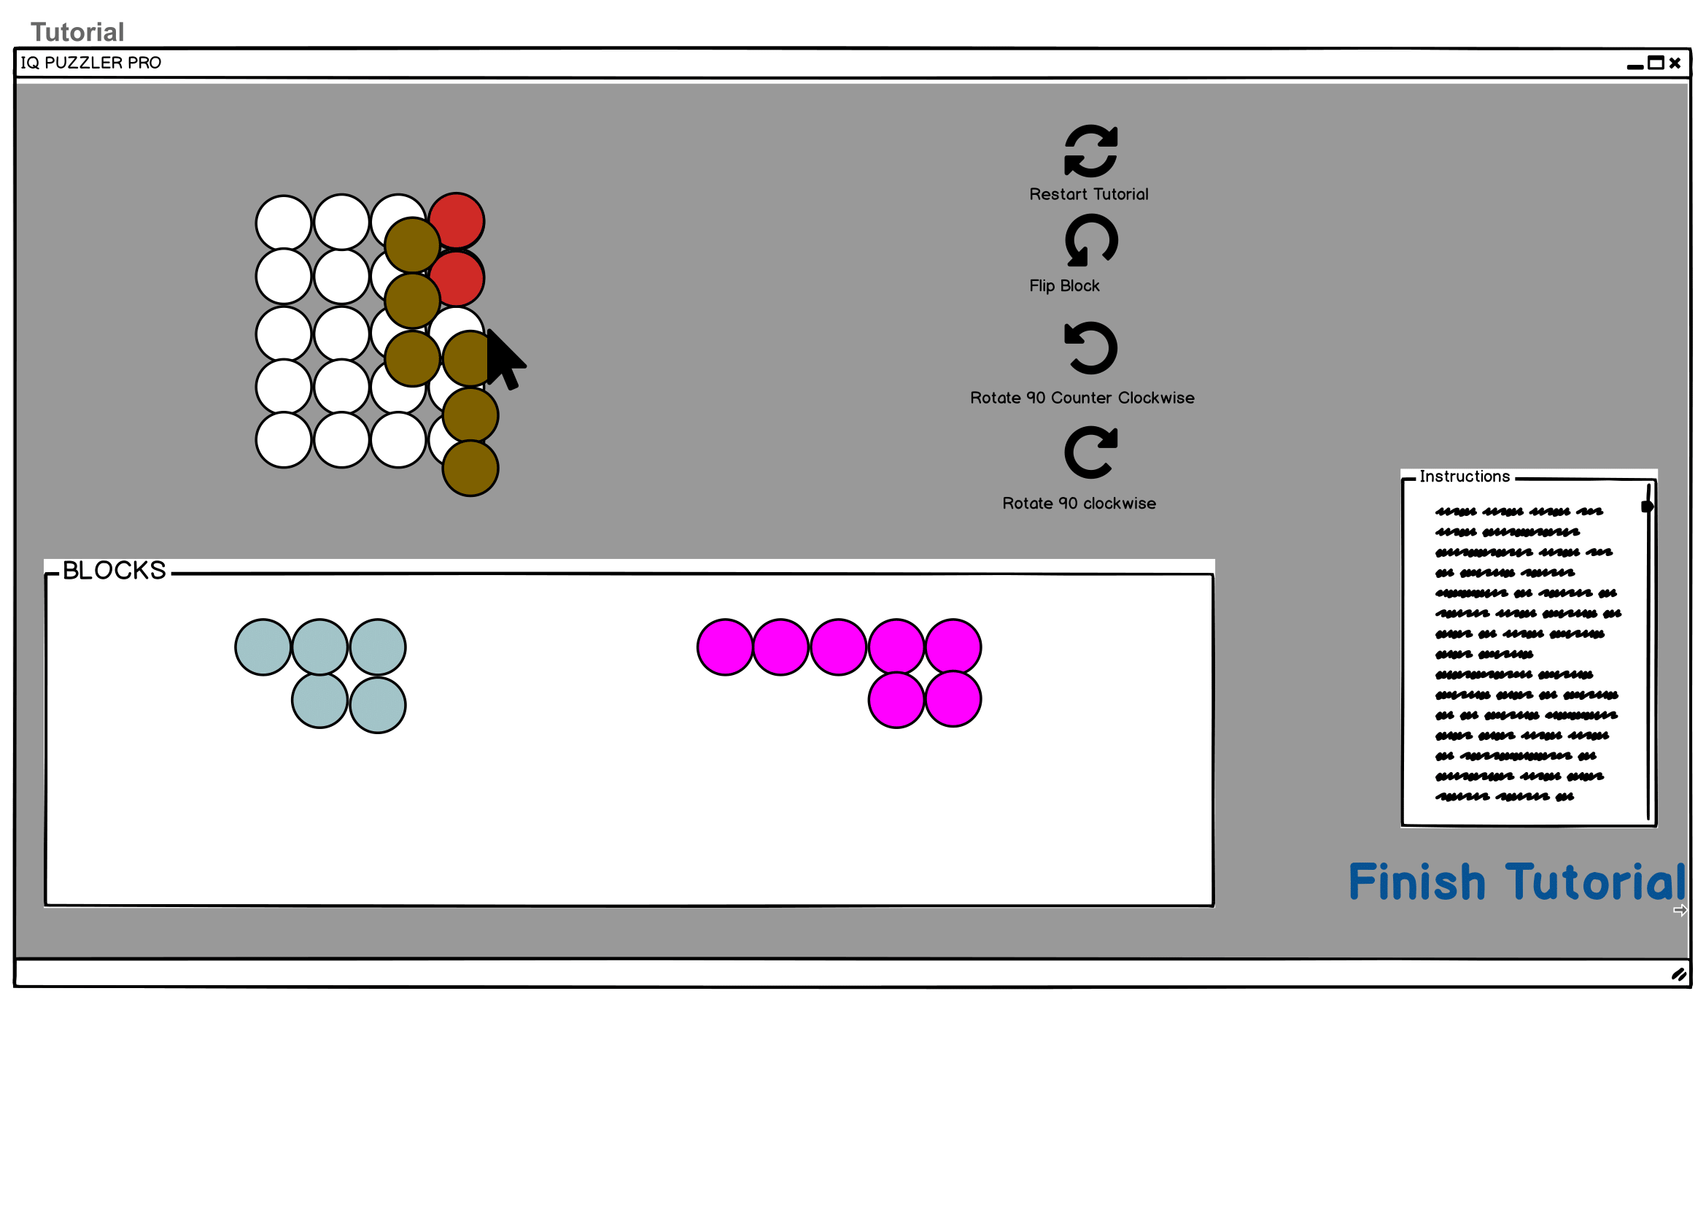

Tutorial Screen will be showing a simple game with Instructions. Board with less dimensions and less blocks will help users to be familiar. Right of the board, there will be same buttons as Solo Play Game Screen and their function will be the same.

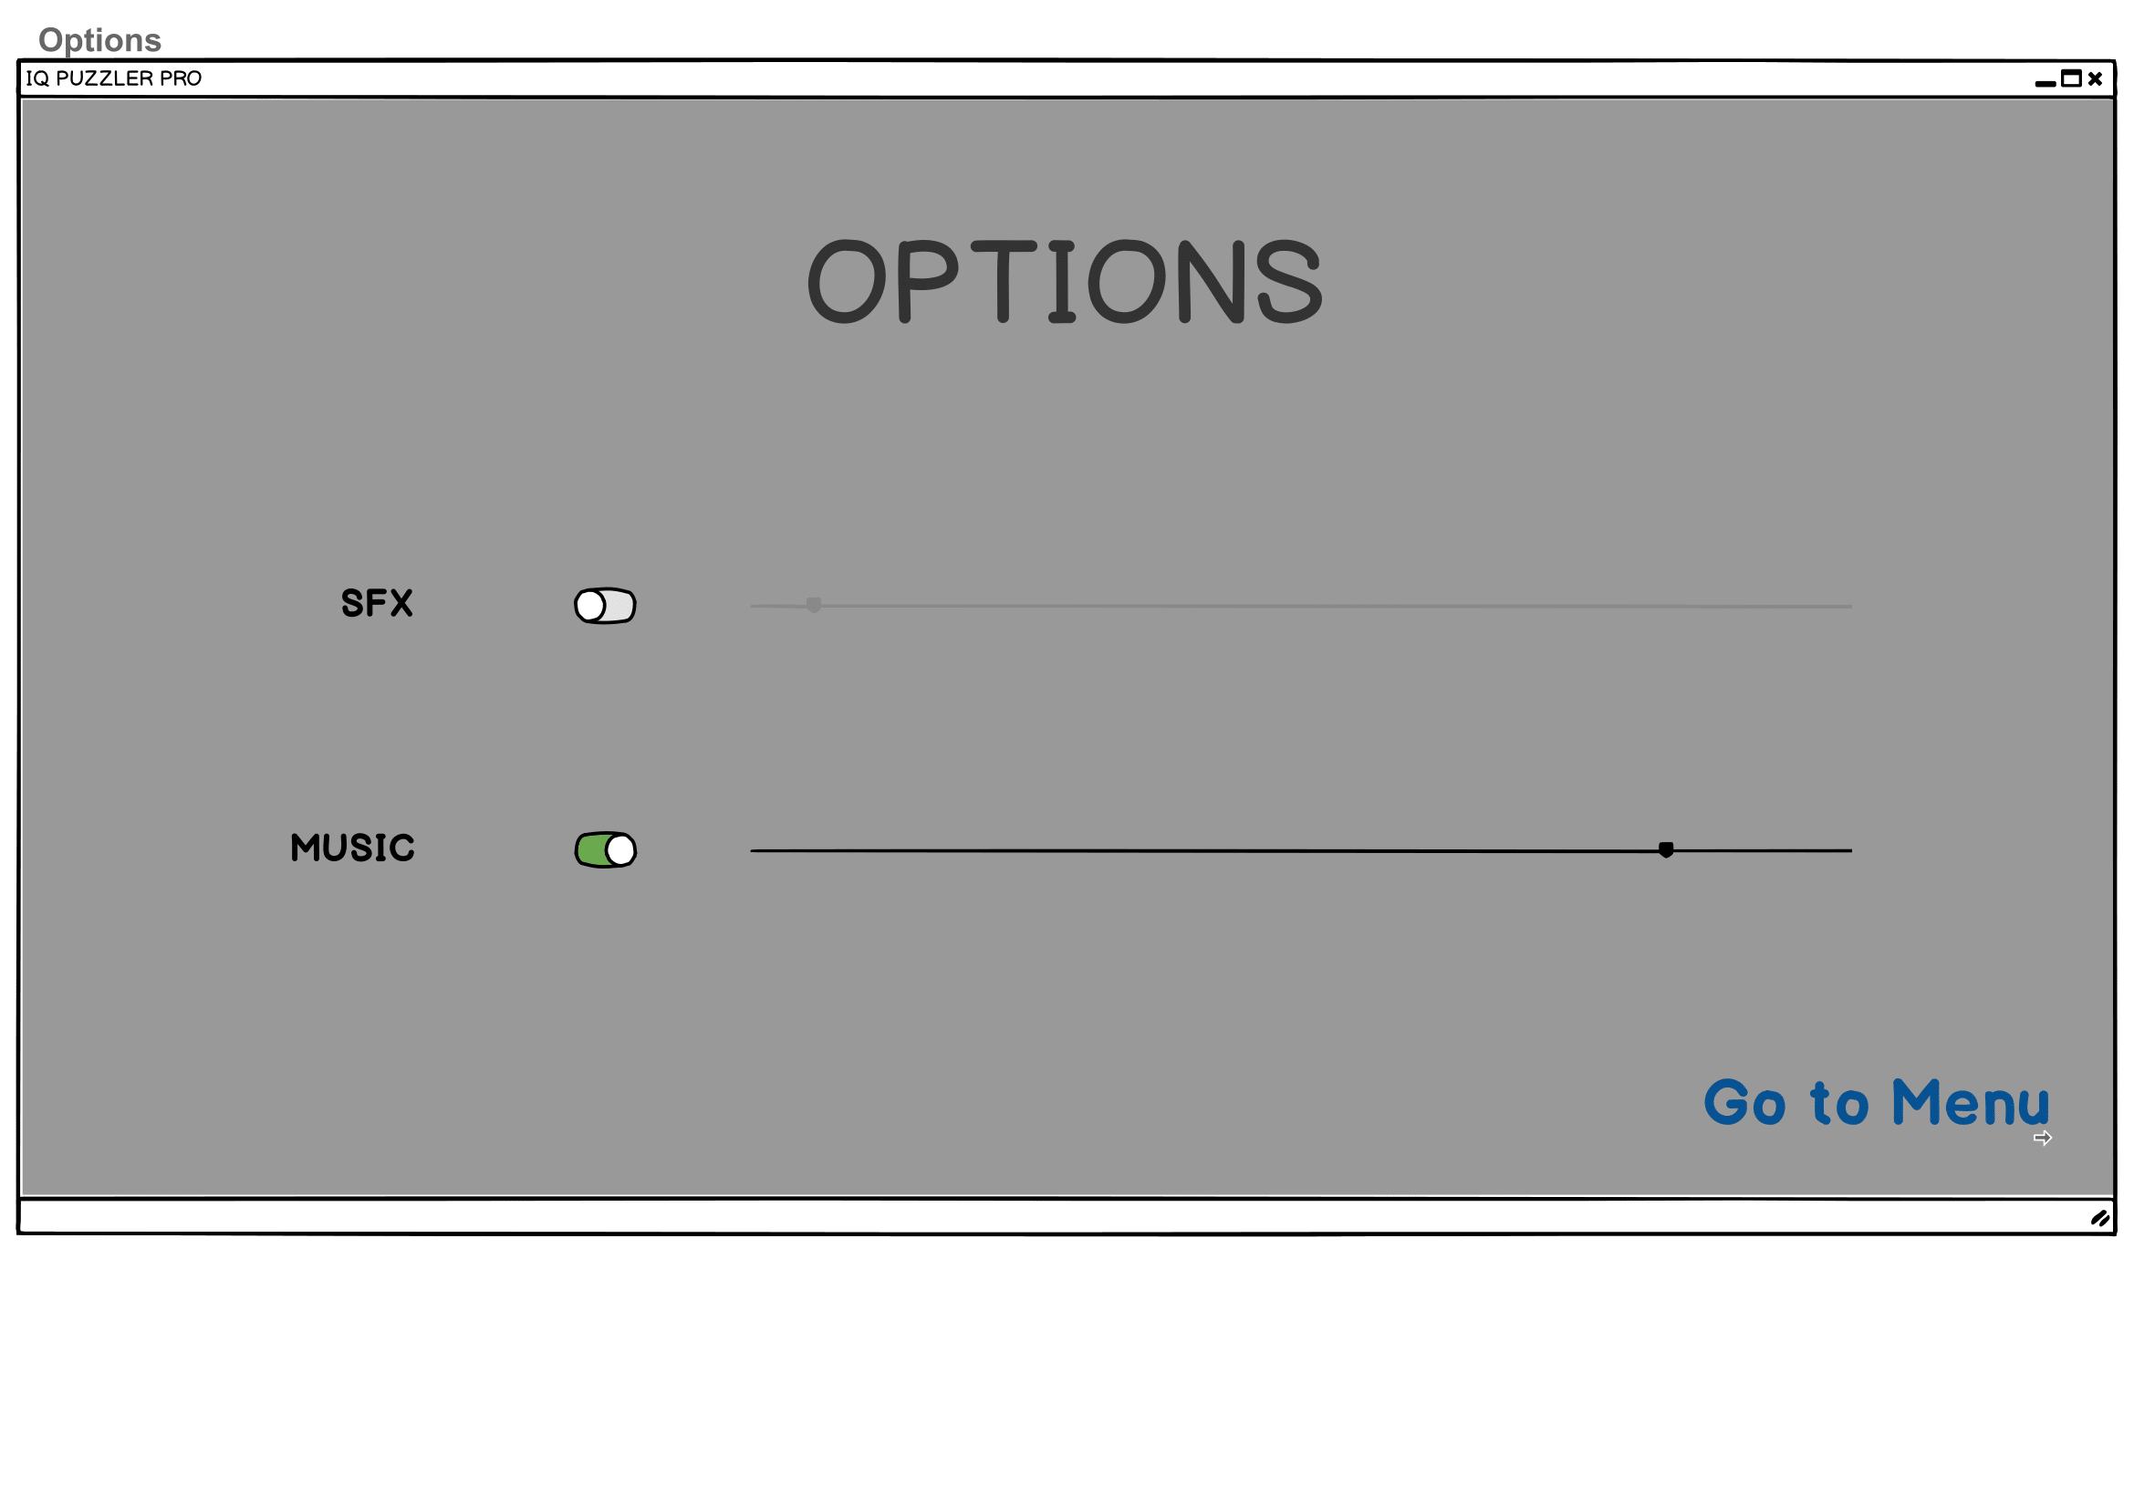

Options Screen is for setting volumes of sound effects and music by sliding. Also there are buttons to mute each of them. Clicking Go to Menu will be directing users to Welcome Screen.

Better Resolution Can Be Seen From:

https://github.com/csLover1337/Elon-s-musk/blob/master/Reports/User%20Interface%20Mockup.pdf

6. Glossary & References

IQ Puzzler Pro:

Single player puzzle game consisting of 12 puzzle pieces in the form of beads molded together into different shapes. The goal of each level is to fit each of the puzzle pieces together onto a 5x11 grid to create a solid rectangle.

Map:

The structure of the puzzle. It includes the size of the board and the puzzle pieces selected. The included puzzle pieces can be moveable or not, which also is stored in the map.

Custom Map:

The map created by a player.

Level:

A puzzle that is preloaded in the application.

PuzzleObject:

The puzzle pieces used to fill the board in the puzzle.

References

IQ Puzzler Pro (the board game) by Smart Games

http://www.bowdoin.edu/~ltoma/teaching/cs210/fall07/Labs/Tetris/tetris1/Tetris1.html